|  |  |  |
| --- | --- | --- |
| **C:\Users\mgenc\AppData\Local\Microsoft\Windows\INetCache\Content.Word\marmara_universitesi_logo.jpg** | **MARMARA UNIVERSITY**  **INSTITUTE OF PURE AND APPLIED SCIENCES** | **C:\Users\mgenc\AppData\Local\Microsoft\Windows\INetCache\Content.Word\fbe_logo_orjinal.jpg** |

**MANAGEMENT INFORMATION SYSTEMS**

**(NON-THESIS PROGRAM)**

**e-CRM**

**Meriç GENÇ 924916012**

**Miraç AYDIN 924917021**

**Term Project**

**Term Project Supervisor**

**Asst. Prof. Özlem Şenvar**

**ISTANBUL, 2017**

Table of Contents

[**1. Introduction 3**](#_Toc501837822)

[**2. e-CRM Concept 3**](#_Toc501837823)

[**2.1. Electronic Customer Relationship Management (e-CRM) 3**](#_Toc501837824)

[**2.2. e-CRM Tools and Scope 5**](#_Toc501837825)

[**3. Benefits of e-CRM 6**](#_Toc501837826)

[**3.1. Cost Reduction and better efficiency 6**](#_Toc501837827)

[**3.2. Increased customer loyalty and improved customer service 7**](#_Toc501837828)

[**3.3. More Effective Marketing 8**](#_Toc501837829)

[**4. Implementation of e-CRM 8**](#_Toc501837830)

[**5. Key factors in implementing e-CRM 10**](#_Toc501837831)

[**6. Challenges in e-CRM and Solutions 11**](#_Toc501837832)

[**7. Distinction between CRM and e-CRM 13**](#_Toc501837833)

[**8. Technological Differences between CRM and e-CRM 15**](#_Toc501837834)

[**9. Conclusion 16**](#_Toc501837835)

[**10. References 17**](#_Toc501837836)

Abstract

E-CRM is constituted of traditional CRM and e-business applications in market. E-technology is consisted of internet, e-mails, smart-phones and other interactive medias. These components transform traditional CRM into e-CRM. The study describes e-CRM concept and some opportunities and challenges of it.

# **Introduction**

Companies are exposed to face challenging and competitive environment because of globalization and technological developments. Companies also focus on customer relationships more to increase revenue and profitability efficiently (Constantions and Christons, 2003).

If companies focus on new customers, they also have to focus on customer relations in order to steady. In other words, business units cannot establish relationship with customers unless they meet expectations of their clients (Alvandi and Sarv kalaei, 2008).

In the past years, how to interact with customers was examined in form of CRM. However, in this new era, IT has a great influence on communications with customers. Thus, this new concept is called as e-CRM (Sophonthummapharn, 2009).

# **e-CRM Concept**

## Electronic Customer Relationship Management (e-CRM)

Electronic Customer Relationship Management does not vary from essentially CRM. Development in IT technologies have increased the scope of CRM implementation in business and it leads to the rising of e-CRM concept. E-CRM improves the customer development, customer retention and customer acquisition (Feinberg et. al., 2002).

“The *term electronic customer relationship management (e-CRM) is an approach that uses technologies such as (web sites, email, data capture, data warehousing and data mining) to maximize sales to existing customers and encourage continued usage of online services (*Chaffey,2007).”

E-CRM can reduce some costs for business organizations such as administrative costs operational costs. Hence, it is adding value to business. Furthermore, e-CRM can be integrated to back office systems for improving efficiency and cost savings (Harfoushi ,2003).

e- CRM systems provide customers with browser-based window to place orders, control order status, inspect buying history, ask about more additional information on products, send e-mails. Contemporary e-CRM systems support marketing, sales and service unlike traditional CRM (Wang MY, 2007).

Customer Relationship management in the electronic environment is a very complex and is a process which based on high technology. The most important factor in the success of e-CRM is that all technological instruments used are compatible with each other. However, it is not possible that to be CRM Company by simply purchasing CRM software packages that will implement e-CRM applications. First of all,there is a need for a perspective that holds the customer in the foreground (ITO, 2009).

## 2.2. e-CRM Tools and Scope

In terms of Information Technologies, the main tools of E-CRM are:

* Instant customer assistance support
* E-Mail Management
* Search engine
* Multi-Language Customer Support
* Content Management

The E-CRM system includes the following activities:

* Sales and Order management from business to business (B2B) or business to customer (B2C)
* Online Sales Platform
* Web Catalog Management
* Information Security Systems
* Communication systems for re-communicating with the customers such as conference communication system, automatic response system, e-mail communication, customer service, marketing automation, multilingual support

**Figure 1.** CRM applications link customer touch points to front and back office functions

**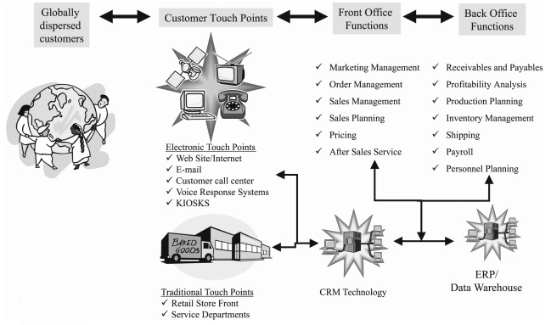**

**Source:** Understanding customer relationship management People, process and technology, Chen and Popovich, 2003, p-674.

# Benefits of e-CRM

By using convenient e-CRM implementation, the following aims can be achieved:

## **Cost Reduction and better efficiency**

Data analysis is extremely important for e-CRM. By using data analysis, companies can save valuable relationships between set of data (whatis.com, 2001; Electronic Customer Relationship Management: Benefits Considerations, Pitfalls and Trends, Scullin et al.). Moreover, customer data can be integrated to single database. In this way, it can allow marketing teams and other departments in company to work toward common goals by using the same statistics (ephany.com 2001; Electronic Customer Relationship Management: Benefits Considerations, Pitfalls and Trends, Scullin et al.). E-CRM can also reduce customer service costs by enabling self-service features such as search functions and order delivery status (bdc.ca, Business Development Bank of Canada, E-commerce for retail: The benefits of using a CRM system).

## **Increased Customer Loyalty and Improved Customer Service**

E-CRM collects customer information and stores it in a central repository. This situation enables company to meet customers` needs easily. E-CRM provides some technologies such as instant helpdesk, search engines, e-mail management, content management and multi-language support. With e-CRM systems, company can:

* Receive, update and close order remotely more properly.
* Provides access to proven solutions.
* Subscribe to product-related information and software patches ([peoplesoft.com](http://www.peoplesoft.com), 2001; Electronic Customer Relationship Management: Benefits Considerations, Pitfalls and Trends, Scullin et al.).

Personalization is very important tool for implementing for customer loyalty (Waltner, Charles “CRM makes on-line Shopping Personal”, InformationWeek, 2001; Electronic Customer Relationship Management: Benefits Considerations, Pitfalls and Trends, Scullin et al.). The personalization concept is a timesaving mechanism that drives the advertising and content displayed on a web site based on customer interest. Personalization software tools use data from many sources such as customer database, transaction systems. Thus, it can create real-time profiles for each customer. Personalization is very effective on business-to-business sites (Greenberg, Paul, Capturing and Keeping Customers in Internet Real Time, McGraw-Hill,2001; Electronic Customer Relationship Management: Benefits Considerations, Pitfalls and Trends, Scullin et al.).

For example, every Amazon customer gets personal recommendations for books based on Amazon’s personalization technology (Kennedy, 2006).

E-CRM on business organizations improves sales through customer profiling, automating campaign management, email marketing, etc. All of these lead to customer loyalty and customer lifetime value (Harfoushi, 2003).

## **More Effective Marketing**

In a competitive marketplace, firms have to work hard to have any added value. They have to work with customers and to discover ways to run the business more efficiently for themselves and more effective for the customers. Therefore, companies have to become much more active and strategic in order to accomplish customers’ satisfaction (Sunny and Abolaji, 2015).

Grouping customers according to their need similarities allows a company to effectively market specific products to members of the targeted groups.

# Implementation of e-CRM

In implementing of e-CRM, some IT tools are used such as e-mails, auto responders etc. The capability of these tools can be measured in various issues:

1. The first being level of interface (i.e., how much can an application allow the company to get up close and personal with the customer). This issue was divided into high (very close) and low (not very close).
2. The second issue that marketers must consider is the actual cost of implementing and maintaining the tool. Costs were also divided into high and low, but they were based on a relative scale rather than an absolute scale.
3. The third scale is the level of personalization, which means how much using a tool can allow the company to see the customer's behavior patterns and cater to his needs accordingly. Generally, technology plays an active role in providing personalized service.
4. Finally, the actual number of users that the tool could provide too at one point in time is evaluated (Mehta, S. S, Dalal, G., Balasuandram, M., (2001), “Customer Relationship Management: Strategies for the Internet”, Journal of the Academy of Information and management Science, Vol. 4, No. 1, pp.19-33; Tavana et al, Electronic Customer Relationship Management and Its Implementation in Business Organizations, 2013).

**Table 1**: Implementation framework of e-CRM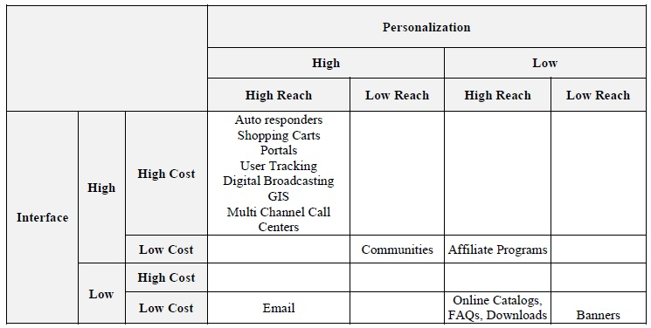

**Source**: Mehta, S. S, Dalal, G., Balasuandram, M., (2001), “Customer Relationship Management: Strategies for the

Internet”, Journal of the Academy of Information and management Science, Vol. 4, No. 1, pp.19-33.

# Key factors in implementing e-CRM

Implementing a successful strategy of CRM in companies depends on the three key factors:

* **Implementation of new technologies:** CRM implementation requires some changes in the organization’s infrastructures and implementing new technologies such as new business rules, databases, information technology, etc.; these changes lead to useful and effective changes in the organization.
* **Training of employees:** In the field of interaction and contact with customers, employees must pass some specialized and practical training courses in order to effectively communicate with customers and gain the ability to use new technologies.
* **Review the processes and design new processes**: Firms without logical design of the processes cannot achieve to their goals. Firms must define their business needs and goals first and then in order to achieve to these needs and they must improve and develop the processes associated with CRM. Re-engineering of the business processes is one of efficient tools in this sector (Mohammadi, 2013).

# Challenges in e-CRM and Solutions

Some of the challenges in implementing e-CRM and how to cope with them are as follows:

**Poor understanding of commercial process:** Before purchasing of e-CRM, all commercial process of organization has to be controlled.

**Weakness in the software producer company:** Before purchasing of e-CRM software for organization, software producer should be evaluated to ensure that producer company can continue its business life. Since, in future, e-CRM software company must support company.

**Project size:** If there is no appropriate economic condition in the market, the first implementation of a small trail e-CRM system seems to be reasonable.

**Lack of technical knowledge:** In some cases, the cost and time of implementing an e-CRM can rise and it tires the customers. Therefore, simultaneous attention to the customer and technology seems to be effective in the success of these projects (Jarahi, M.H., Saeida Ardakani, S., Zareian, M., (2009), "The role of IT in the e-CRM establishment" Journal of parks and growth centers, Vol.6, No. 21, pp. 49-59; Tavana et al, Electronic Customer Relationship Management and Its Implementation in Business Organizations, 2013.)

**Figure 2:** e-CRM Solutions Development Methodology

**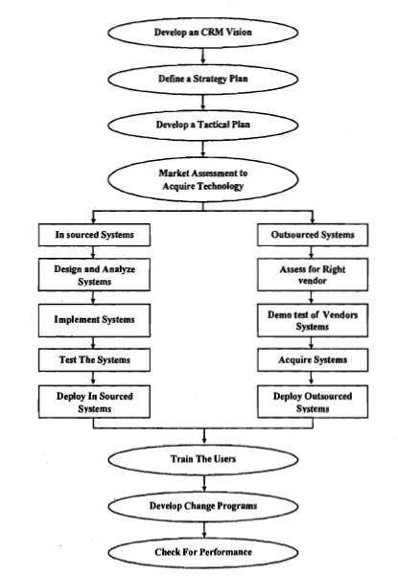**

**Source**: Jafarnejad et al, Toward e-CRM: An e-CRM Solution Development Methodology 2007, p.85.

# Distinction between CRM and e-CRM

The distinction is made between CRM and e-CRM, based on three parameters of Approach, Cost, and Service (Jafarnejad et al. 2007)

**Approach**: It means that CRM tries to make full use of many different channels to reach the customer. Therefore, CRM has the fragmented view of each customer across different channel. In other words, the same customer is viewed differently when seen from different channel perspectives. On the other hand, e-CRM has the consolidated approach that integrate all different channels to reach the customers. This concept makes the channel integration possible, i.e whether a customer interacts through Telephone, Fax. E-mail or any other communicate channel, it is seen as a same customer throughout the way (Jafarnejad et al. 2007).

**Cost**: Cost is the major factor for which organizations are always worried. The overall cost of CRM is high, because different channels must be supported separately by organization. However, organizations can reduce communications costs by using e-CRM that based on internet infrastructure (Jafarnejad et al. 2007).

**Service Parameter:** CRM is using different channels to communicate with the customers, and it gives us an efficient service. Because an organization cannot see the consolidated view of a customer, therefore not so much value is created for both the customers and organization when a customer interacts with the company. Efficiency is doing the things right. In CRM, it is concern that customer while interacting with the company is treated well, and customers’ needs to be solved in a right way. It is difficult job in CRM to think of personalized service. Effectiveness means that doing the right things. Besides, e-CRM give us a personalized services so that more value is created for both the customers and company and e-CRM wants to make effective use of web channels (Jafarnejad et al. 2007).

**Table 2**: Shows the difference between CRM and e-CRM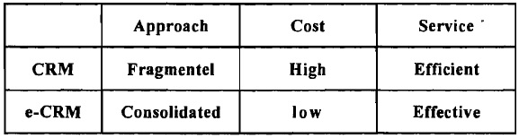

**Source:** Source Asif et al, 2004; Jafarnajad et.al. Toward e-CRM, 2007, p.81.

**Table 3**: The difference between CRM and e-CRM

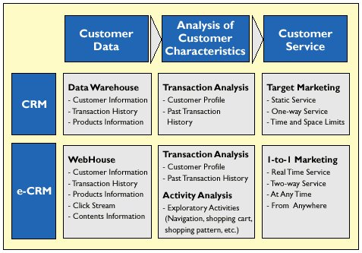

**Source**: Pan, S. and Lee, J.,"Using E-CRM for A Unified View of the Customer”, COMMUNICATIONS OF THE ACM April 2003, pp.95-99; Harb and Abu-Shanab, Electronic Customer Relationship Management (e-CRM) in Zain Company, 2009, w.p.

# Technological Differences between CRM and e-CRM

**Table 4:** Technological Differences between CRM and e-CR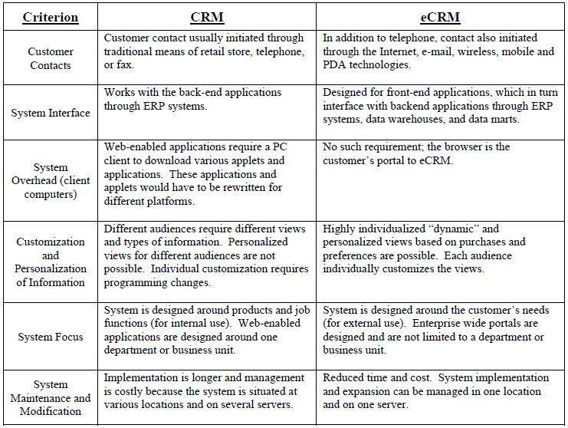M

**Source:** Technological differences between CRM and E-CRM, Chandra and Strickland, 2004, p.412.

# Conclusion

Customers are always interested in the quality of products and in how quickly companies can meet their needs. In recent years, internet technology has developed very rapidly. It is extremely important that internet technologies be used in customer relationships. Because internet technologies reduce the costs of firms, enable more customers to reach by providing globalization capabilities. Customers are always at the center of the policies of the companies. For this reason, companies need to understand the CRM and e-CRM philosophy in order to increase their profits and income.

# References

2001; Electronic Customer Relationship Management: Benefits Considerations, Pitfalls and Trends, Scullin et al

Alvandi, N., Mirzaei sarv kalaei, R., (2008), “ The Role of CRM in Business to Business Electronic Commerce”, 5thNational Congress of the Electronic Commerce, Islamic Republic of Iran Ministry of Industry, Mining and Trade, Deputy for planning and Economic Affairs, Tehran.

Chaffey, D. E-Business and E- Commerce Management, Prentice Hall (Pearson Education Limited), 2007; Harb& Abu-Shanab, Electronic Customer Relationship Management (e-CRM) in Zain Company.

Constantions, J.S., Christons, S., (2003), “CRM and Customer Centric Knowledge Management, Marketing

CRM – (Customer Relationship Management), ITO yayinlari http://www.ito.org.tr/Dokuman/eTicaret/04.02.03.02.57.pdf, 2009 p.5-6.

Feinberg, R. A., Kadam, R., Kokama, L. and Kim, I., The state of electronic customer relationship management in retailing, International Journal of Retail & Distribution Management, Vol. 30, No. 10 pp 470-481, 2002; Osama K. Harfoushi, Electronic Customer Relationship Management Usability Model: Improving the Usability of eCRM Systems in Jordan.

Greenberg, Paul, Capturing and Keeping Customers in Internet Real Time, McGraw-Hill,

Harfoushi , Electronic Customer Relationship Management Usability Model: Improving the Usability of eCRM Systems in Jordan, 2003.

<http://www.ephany.com/market/crm_benefits.html> 2001; Electronic Customer Relationship Management: Benefits Considerations, Pitfalls and Trends, Scullin et al.

<http://www.peoplesoft.com/en/us/products/applications/crm/product_content.html> 2001; Electronic Customer Relationship Management: Benefits Considerations, Pitfalls and Trends, Scullin et al.

<https://www.bdc.ca/en/articles-tools/marketing-sales-export/sales/pages/benefits-crm.aspx> , Business Development Bank of Canada, E-commerce for retail: The benefits of using a CRM system.

Intelligence & Planning, Vol.19, No.2, pp.136-9.

Jafarnejad et al, toward e-CRM: An e-CRM Solution Development Methodology, 2007.

Jarahi, M.H., Saeida Ardakani, S., Zareian, M., (2009), "The role of IT in the e-CRM establishment" Journal of parks and growth centers, Vol.6, No. 21, pp. 49-59; Tavana et al, Electronic Customer Relationship Management and Its Implementation in Business Organizations,2013.

Kennedy, Electronic Customer Relationship Management (eCRM): Opportunities and Challenges in a Digital World, 2006.

Mehta, S. S, Dalal, G., Balasuandram, M., (2001), “Customer Relationship Management: Strategies for the Internet”, Journal of the Academy of Information and management Science, Vol. 4, No. 1, pp.19-33; Tavana et al, Electronic Customer Relationship Management and Its Implementation in Business Organizations,2013.

Mohammadi, E., (2003), "Customer oriented", Rasa publication, Tehran; Tavana et al, Electronic Customer Relationship Management and Its Implementation in Business Organizations, 2013.

Osama K. Harfoushi, Electronic Customer Relationship Management Usability Model: Improving the Usability of eCRM Systems in Jordan,2003.

Sophonthummapharn, K., (2009), “The adoption of techno-relationship innovations: A framework for electronic Customer relationship management”, Marketing Intelligence & Planning, Vol. 27, No. 3, pp. 380-412.

Sunny and Abolaji , Electronic Customer Relationship Management (E-CRM) & Marketing Performance: Empirical Evidence from Nigeria Telecom Sector, 2015.

Waltner, Charles “CRM makes on-line Shopping Personal”, InformationWeek, 2001; Electronic Customer Relationship Management: Benefits Considerations, Pitfalls and Trends, Scullin et al

Wang MY. Measuring E-CRM service quality in the library context: A preliminary study. The Electronic Library. 2007;26(6): 896-911; Sunny and Abolaji, e-CRM & Marketing Performance: Empirical Evidence from Nigeria Telecom Sector.

whatis.com, 2001; Electronic Customer Relationship Management: Benefits Considerations, Pitfalls and Trends, Scullin et al.